Faculty Name:_Asif Hassan___ Date ________________

Course/Class:______________ Semester____________

EE- 222: Microprocessor Systems

**LAB 03: Declaration and Manipulation of Variables in Assembly Language**

|  |  |  |  |  |
| --- | --- | --- | --- | --- |
| Student name | Reg. No. | Lab Report Marks / 10 | Viva Marks / 5 | Total/15 |
| **M.Ahmed Nisar** | **173200** |  |  |  |
| **M.Usman** | **194432** |  |  |  |
| **M.Haris Rehman** | **182797** |  |  |  |
|  |  |  |  |  |

# LAB 03: Declaration and Manipulation of Variables in Assembly Language

**Objective:** The aim of this lab is to practice declaring and manipulating variables in assembly language programs and verifying the outputs.

Exercise 1: Write the value of register in blank given in front of each mov and arithmetic instruction once you are done Assemble and run the following program to verify you answers.

TITLE Add and Subtract, (AddSub2.asm)

This program adds and subtracts 32-bit unsigned

integers and stores the sum in a variable. INCLUDE Irvine32.inc

. INCLUDE Irvine32.inc

.data

var1 DWORD 10000h ;val1 declared as a variable of type DWORD and initialized

var2 DWORD 40000h

var3 DWORD 20000h

finalVal DWORD ?

Val1 WORD 100H

Val2 WORD 200H

arrayB BYTE 10H, 20H, 30H, 40H

arrayW WORD 100h, 200h, 300h, 400h

arrayD DWORD 10000H, 20000H

.code

main PROC

mov eax,var1 ; eax= 10000h

add eax,var2 ; eax= 50000h

sub eax,var3 ; eax= 30000h

mov finalVal,eax ; finalVal= 30000h

call DumpRegs

mov eax, 0 ; eax= 0

mov ebx, 0 ; ebx =0

mov ecx, 0 ; ecx =0

mov ax, val1 ; eax= 00000100

call dumpregs

Mov bx, val2 ; bx= 0200

Mov cl, arrayB ; cl= 10h

Mov cl, [arrayB+1] ; cl= 20h

Mov cl, [arrayB+2] ; cl= 30h

Mov ax, arrayW ; ax= 0100h

Mov ax, [arrayW+2] ; ax= 0200h

Mov bx, [arrayW+4] ; bx= 0300h

Mov ecx, arrayD ; ecx= 00010000h

Mov ecx, [arrayD+4] ; ecx= 00020000h

Call dumpregs

exit

main ENDP

END main

**Exercise 2:** Note down the contents of registers EAX, EBX and ECX as displayed by the program. Do the registers contents match the expected results?

**SCREENSHOT**

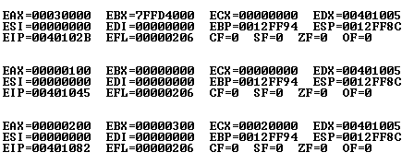

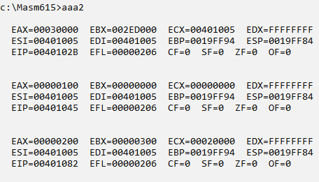

**Exercise 3:** Write code to achieve the following:

1. Define two 8 bit variables var1, and var2, and initialize these to 20, and 30.

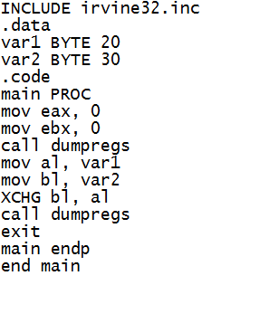

1. Swap the contents of var1 and var2 variables using registers. Display the contents of the registers.

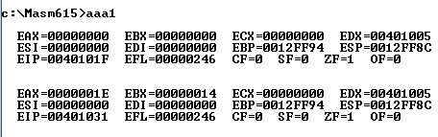

**Exercise 4:** Write codes to evaluate the arithmetic expression “5+(6-2)”, by

1. Using one register only

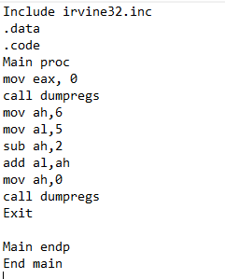

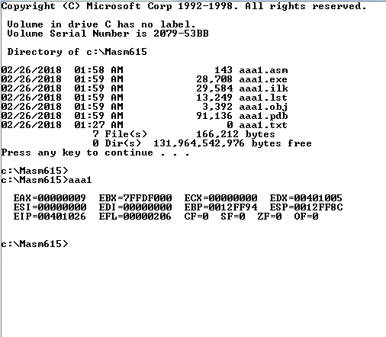

1. Using two registers only

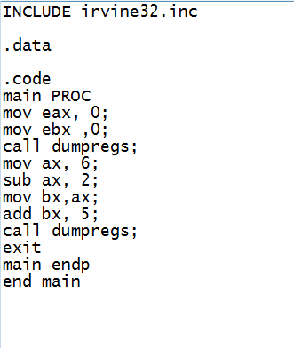

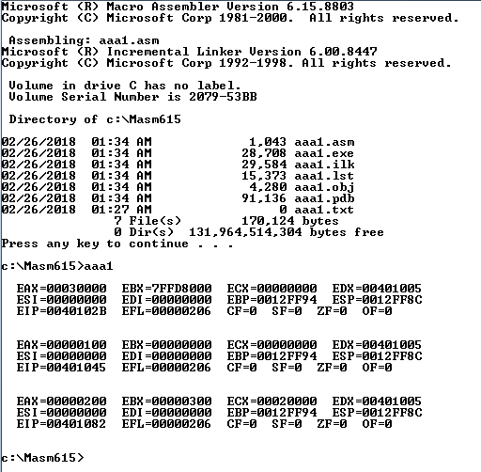

1. Using three registers

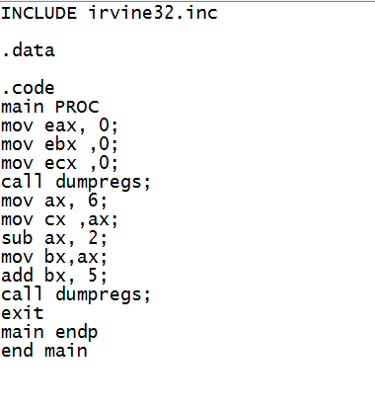

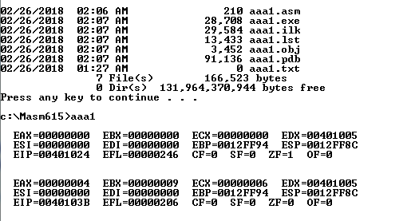

**Exercise 5**: Explain why each of the following MOV statements are invalid?

.data

bVal BYTE 100

bVal2 BYTE ?

wVal WORD 2

dVal DWORD 5

.code

mov ds,45 ; ***ds is undeclared variable and ds is value can’t directly assign to mem element***

Mov esi,wVal ; ***cannot move into index registers***.

Mov eip,dVal ; ***cannot move into pointer registers.***

mov 25,bVal ; ***cannot move into immediate memory.***

mov bVal2,bVal ; ***cannot move from memory to memory.***